# [**Christopher Meloni on returning to the ‘Law & Order’ universe**](https://nypost.com/2020/07/06/christopher-meloni-on-returning-to-the-law-order-universe/)

By [Michael Starr](https://nypost.com/author/michael-starr/)

July 6, 2020 | 6:54pm

[Enlarge Image](https://nypost.com/2020/07/06/christopher-meloni-on-returning-to-the-law-order-universe/#)

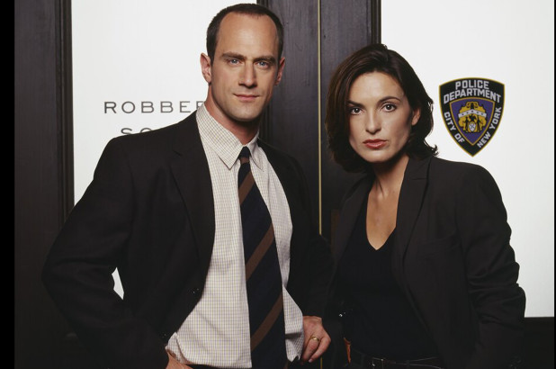

Christopher Meloni as Detective Elliot Stabler and Mariska Hargitay as Detective Olivia Benson.NBCUniversal via Getty Images

#### **MORE ON:**

### [**LAW & ORDER**](https://nypost.com/tag/law-order/)

## ['Law & Order' spinoff teases 'devastating' loss for Christopher Meloni's Stabler](https://nypost.com/2020/06/16/law-order-spinoff-teases-huge-loss-for-melonis-stabler/)

## [Celebrities who got fired from their TV shows for alleged racism](https://nypost.com/article/celebrities-who-got-fired-from-their-tv-shows-over-racism-claims/)

## ['FBI' star Jeremy Sisto loves kick scooting around the city](https://nypost.com/2020/02/14/fbi-star-jeremy-sisto-loves-kick-scooting-around-the-city/)

## [Can you believe these TV shows lasted this long?](https://nypost.com/2016/03/14/can-you-believe-these-tv-shows-lasted-this-long/)

Chris Meloni says his [return to the “Law & Order” roster](https://nypost.com/2020/05/02/christopher-meloni-to-return-to-law-and-order-svu/) as Elliot Stabler — in the fall spinoff series “Law & Order: Organized Crime” — took him by surprise.

“It truly came about by [series creator] Dick Wolf calling and saying he wanted to discuss a project,” Meloni, 59, tells The Post. “I was like, ‘Oh, really? OK.’ I was shocked.

“I never thought this was going to happen, but the circumstances for me changed,” he says. “So ‘yes’ became the correct answer.”

Meloni left “Law & Order: SVU” in 2011 after playing Det. Stabler for 12 seasons opposite Mariska Hargitay’s Det. Olivia Benson (who now holds the rank of Captain as “SVU” enters its 22nd season).

The reasons for his departure were never confirmed and Meloni was written off the NBC series — his exit explained in the Season 13 premiere when it was revealed that Stabler, married with five kids, had retired from the force following a deadly, self-defense shooting in the Season 12 finale

“How I left was a different issue and had nothing to do with the ‘Law & Order’ people, the ‘SVU’ people or with Dick Wolf,” Meloni says. “I left with zero animosity, but I did leave clearly and open-eyed in going forward and finding new adventures.

“I was like, ‘That’s what I want to do, keep moving forward,’ ” he says. “I had done the ‘Law & Order’ way of storytelling, which they do really well, and I was interested in telling stories from a different angle — whether comedic or inhabiting a new world or doing it on different platforms.”

Since leaving “SVU,” his long TV resume includes appearances on “True Blood,” “The Handmaid’s Tale,” “Pose” and “Veep,” starring roles in “Surviving Jack” (Fox) and “Happy!” (Syfy) and two “Wet Hot American Summer” movies on Netflix. In “MAXXX,” premiering July 28 on Hulu, he plays Don Wild — a drug-fueled, perpetually tan, earring-and-kilt-wearing record producer backing the solo comeback of onetime Boy Band wonder MAXXX (played by series creator O-T Fagbenle).

#### ***SEE ALSO***



### ['Law & Order' spinoff teases 'devastating' loss for Christopher Meloni's Stabler](https://nypost.com/2020/06/16/law-order-spinoff-teases-huge-loss-for-melonis-stabler/)

“Law & Order: Organized Crime” finds Stabler [returning to the NYPD following “a devastating personal loss”](https://nypost.com/2020/06/16/law-order-spinoff-teases-huge-loss-for-melonis-stabler/) as he’s put in charge of a task force cracking down on mob activity. “He must adapt to a criminal justice system in the midst of its own moment of reckoning,” according to NBC. “Throughout the series, we will follow Stabler’s journey to find absolution and rebuild his life …”

Production on the series has been delayed due to the pandemic shutdown; when the fall season (eventually) begins, it will air Thursdays at 10 p.m. — immediately following “SVU.”

“Dick gave me a general brush stroke of the unit that Elliot will be a part of,” Meloni says. “The whys, what fors, what brings him back to the fold and where he’s been.” As for Stabler’s “devastating personal loss,” Meloni says “we’ll leave it at that.”

He does say, though, that he expects Stabler and Benson to reunite in crossover episodes.

“It just has to be,” he says. “Benson and Stabler are inextricably linked, locked and connected. I think there is truly and deeply a worthwhile, inherent drama in exploring that relationship and the complexity of how Stabler left — the unresolved emotions both characters feel and how the fans feel.

“How my character left was really unsatisfying, I think,” he says. “It almost feels that we won’t do one or two [crossover] episodes and move on our merry way.

“I just think there will always be possibilities there,” he says. “People will always be hungry to see how we interact and how that dynamic has changed.”